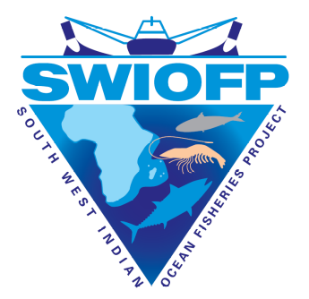

SAILING ORDERS
MFV ROBERTO
Registration N° 10171 (KENYA)
VOYAGE TZN2012C204

SURVEY: Deep-water crustacean trawl survey in Tanzania
START: 29th January 2012
END: 13th February 2012
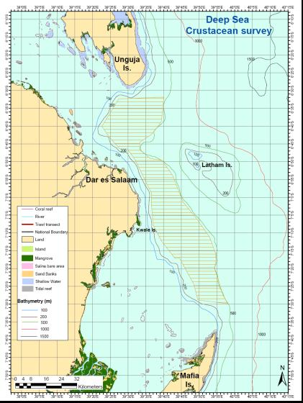

Area A
Area B
Figure1. Map of the study area




PERSONNEL:

N° | Field | Names | Affiliation & nationality | Gender
1 | Cruise leader | Mathew Silas | TAFIRI-TANZANIA | M
2 | Oceanography & Nutrients | Mathias Igulu | TAFIRI-TANZANIA | M
3 | Crustacean Taxonomy | Dickson Stoah | FISHERIES DIVISION-TANZANIA | M
4 | Crustacean Genetics | Saidi Mgeleka | TAFIRI-TANZANIA | M
5 | Fish Taxonomy and Genetics | Mr. Desmond Hayes | ORI – SOUTH AFRICA | M
6 | Biodiversity | Patroba Matiku | TAFIRI-TANZANIA | M

LIST OF ABBREVIATIONS
SWIOFP | South West Indian Ocean Fisheries Project
ORI | Oceanographic Research Institute, South Africa
TAFIRI | Tanzania Fisheries Research Institute

LAND BASED PERSONNEL:
Survey Logistic Coordinator: Teresa Athayde, tathayde@swiofp.net, +262 692 570 349
Tanzania Focal Point: Dr. Baraka Kuguru, barakakuguru@gmail.com
Director General TAFIRI: Dr. Ben Ngatunga bpngatunga@yahoo.co.uk
TAFIRI Dar es Salaam Centre Director Dr. Simon, J. Kangwe jumakangwe@yahoo.com
Ag. Director of Research TAFIRI: Dr. Semvua Mzighani mzighani@yahoo.com
SWIOFP RCC2: Dr. Johan Groeneveld, jgroeneveld@ori.org.za, +27 (0) 78 6747 401

1. SCIENTIFIC RATIONALE

Background
The Tanzanian coast stretches from 5º25’S to 10ºS (approx. 1400km) with several offshore islands at Zanzibar, Pemba and Mafia. Crustaceans have been recognised as an important economical and food resource along Tanzania’s coast, and several recent trawl surveys have been conducted in shallow water under the banners of MACEMP and SWIOFP. Exploratory deep-water trawling off Tanzania by the South African fishing vessel ‘Ocean Surf’ found economically viable quantities of langoustines and deep-water prawns in 2004, but these fisheries were short-lived. Iversen et al. (1984) gives some information on deep-water crustaceans. Despite the earlier deep-water explorations, basic information on the fisheries potential of deep-water crustaceans off Tanzania is unknown. This survey will be exploratory to identify potential deep-water crustacean resources (langoustines, prawns, crabs, lobster) and estimate their biomass.

Aims and Objectives
Tanzania deep-water crustacean survey aims to collect information on deep-water crustacean resources in Tanzania at depths >100 m, using a wet-leased deep-water prawn trawler.
The trawler MFV Roberto will survey the coast of Tanzania from Tanga to the Rufiji River. No survey will be conducted in the Kilwa area, Southern part of Tanzania, since the MFV Roberto is restricted from operating in this area due to frequent pirate attacks.
Survey specific objectives are to:
- Complete 5-7 trawls of 1 hour bottom time per 24 hour period (if catches are large, bottom time can be reduced to 30 minute trawls).
- Log the GPS position, time, depth, speed and duration of each trawl so that the swept area and its location can be determined
- Determine the species composition and quantity (total weight or numbers/species/trawl) of priority crustaceans caught in each trawl net
- Collect biological samples per species (length, sex, and reproductive stage)
- Collect 40 genetic samples per priority species
- Collect additional genetic samples for other species as per request.
- Collect and preserve whole specimens as per request (either frozen or in ethanol / formalin)
- Determine the species composition and quantity (total weight or numbers/species/trawl) of bycatch (fish, sharks, cephalopods, low value crustaceans) caught in each trawl net. Sub-sampling can be used, if required. No distinction to be made between retained and discarded bycatches during sampling.
- Record standard environmental information before each trawl at the surface and sea bottom using the CTD.
- To collect additional data and samples to support approved SWIOFP and national research projects (project proposals and data/ sample requests to be approved by RCC2 before sailing)
- Identify and count seabirds when trawl is deployed and hauled.
- Describe turtle and cetacean inter-actions with the fishing gear.

Outcomes & Deliverables
Deliverables will include:
- Completed survey, including at least 70 trawls to be made;
- Trip report within 1 month of the end of the survey;
- Technical report within 3 months of the end of the survey;
- Effort, catch, biological and environmental data captured onto Nansis database;
- Biological samples collected as per request;
- Genetic samples as specified for crustacean and fish spp.
- Frozen or chemically preserved whole specimen samples as per request;
- Training and capacity building of scientists and observers during the survey;

2. GENERAL CRUISE PLAN

Logistics
The survey will start on the 30th January 2012 and will finish on the 12th of February of the same year. The MFV Roberto will depart from Mombasa, Kenya, on the 29th of January and will arrive in Dar es Salaam, Tanzania on the following day. The vessel will be inspected by Tanzanian Authorities and embark six scientists and four armed guards, and depart in the late afternoon for the survey area.
Mafia channel will be surveyed, according to the sampling schedule. The vessel will arrive to Dar es Salaam in the afternoon of the 12th of February, were, the scientific crew will disembark. Vessel will then sail to Mombasa, Kenya to implement Kenya survey (see below).
Date | Place | Activity
29/01/2012 | Mombasa, Kenya | Sailing from Mombasa, Kenya to Dar es Salaam, Tanzania.
30/01/2012 | Dar es Salaam, Tanzania | Vessel to arrive to Dar es Salaam and to be inspected by Tanzanian authorities; Embarking scientific crew and armed guards; Sailing to survey first trawl station.
01 - 4/02/2012 | Off Dar es Salaam | Sampling area 1
05/02/2012 | Mafia channel | Sailing
06 - 11/02/2012 | Mafia channel | Sampling area 2
12/02/2012 | Dar es Salaam, Tanzania | Sailing and disembarking scientific crew and armed guard; Vessel to sail to its home port Mombasa, Kenya.
13/02/2012 | Mombasa, Kenya | Vessel to arrive to its home port Mombasa, Kenya.
14/02/2012 | Mombasa, Kenya | Vessel to refuel, re-stock and embark scientists, armed guards and materials;
Table 1 – Survey Schedule

3. SURVEY DESIGN AND SAMPLING STATIONS
Historical information from commercial fishing has been used to identify 2 sampling areas along the coast of Tanzania. These two areas are:
- Dar es Salaam (180km²)
- NW Mafia (<220 km²)

The survey will sample these two survey areas with trawling stations being sampled from north to south. Four days in area 1 and six days in area 2 from the south -western part of Latham islands to Mafia as per shown below on Fig. 1.
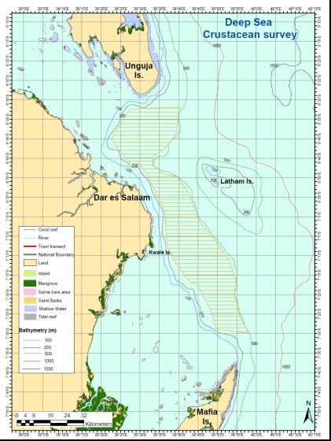

Area A
Area B
Fig 1: map of the study area

Each sampling area extends from 200-600 m depth, and their boundaries are defined on Figure 1. Each sampling area consists of 4 depth strata:
- 200-300 m
- 300-400 m
- 400-500 m
- 500-600 m

In effect this gives a total of 8 blocks to be sampled (2 sampling areas * 4 depth strata). A total of 70 trawls are expected to be completed during the survey.

Given the different sizes of the areas to be sampled and the absence of precise information, subdivision of the numbers of trawls have been proportionally done in order to respect total number of fishing days (10) and total number of trawls planned for the survey (70).

Area | N° days | Day trawls | Night trawls | Total
1 – Dar es Salaam | 4 | 20 | 8 | 28
2- NW Mafia | 6 | 30 | 12 | 42
TOTAL | 10 | 50 | 20 | 70

Area | 1- Dar es Salaam | 1- NW Mafia | Total
200-300 | 7 | 11 | 18
300-400 | 7 | 11 | 18
400-500 | 7 | 10 | 17
500-600 | 7 | 10 | 17
Total trawls | 28 | 42 | 70

Furthermore, not all of the blocks shown above will have the right bottom type for trawling, and some blocks may not be trawlable at all. Trawls remaining where a block could not be sampled fully (or at all) should be moved to another depth or area. Please refer to Annex B for further details on areas to be sampled, historical data and proposed initial positions for trawling.

4. SAMPLING

4.1 Detailed work plan (methodology)
The principal tasks will be to carry out sampling according to the survey plan (see above) as closely as possible, depending on available time and sea conditions. Main activities will include CTD casts, bottom trawling, measuring fishing effort and catch weight by species, biological sampling, genetic sampling, collection of biodiversity data, reporting sightings of marine mammals and seabirds, and logging interactions of mammals, birds and turtles with fishing gear.
Environmental data will be collected at each station, before starting trawling. A CTD will be deployed to collect information such as Sea surface temperature, Oxygen, conductivity and depth profiles; Surface water sample will be collected using a Niskin bottle for quantification of environmental chemical and biological information such as phytoplankton, nutrients, Chl a and salinity. Other environmental variables will be collected at the start of each trawl including: 1) wind strength [Beaufort scale], 2) sea condition, 3) current speed, 4) visibility, 5) depth, 6) bottom-type).
Trawling will be done using a bottom trawls net with a head rope of 27m, bride line of 70-75m and a mesh size 50mm. Trawls will be conducted during day and night time to account for day/night activity rhythms and catchability (see Section 2 above for details). Length of footrope will be recorded for swept-area estimates of biomass.

4.1.1 Environmental Sampling
The following environmental sampling protocol is to be adhered to at all times:

Stage | Description
Step 1 | Once on station and before starting trawling, the vessel will come to a full stop to allow for the collection of environmental data and samples  CTD operating procedures:  - At the start of a profile the CTD must be as near the surface as possible without the device breaking surface  - On the first station of the cruise the CTD must be allowed to stabilize on the surface for three minutes before commencing the dip. On all other stations it is to be stabilized for two minutes.  - The CTD is to be lowered / raised at 0.5 m/s between the surface and the thermocline. Below the thermocline the rate is 1 m/s  - Sampling may not be done 'on the run'.  The following CTD parameters will be collected before starting a trawling station  - Temperature  - Dissolved Oxygen  - Salinity  - Conductivity

Step 1 | - Depth profiles  - Chl a
Step 2 | Collect and record the following environmental parameters from the bridge:  - Wind strength and direction using the Beaufort scale (see appendix C)  - Sea condition  - Current speed estimates  - Transparency (turbidity)  - Depth and Bottom-type from echo-sonar

4.1.2 Bottom Trawling

Bottom trawling is to be conducted:
- At each station;
- Once the CTD is safely back on board;
- By one otter trawl;
- For 1 hour or 30 minutes (from the moment the net touches the sea floor to the moment it leaves the sea floor);
- At a trawl speed of 3 knots;
- During day and night time;
- After every dip, nets should be properly cleaned and rinsed (all meshed organisms to be removed before the trawl is used again).

Trawl Record-keeping
- Record details of the trawl deployment on the data sheets provided, and capture the information onto the Nansis database. The following fields are mandatory:
  - Date and station number;
  - Position at start of trawl (lat; long);
  - Depth at start of trawl;
  - Time at start of trawl;
  - Position at end of trawl (lat; long);
  - Depth at end of trawl;
  - Time at end of trawl;
  - Wind speed and direction;
  - Sea condition;
  - Current speed estimates;
  - Visibility;
  - Bottom type.
- For each net record:
  - Net type;
  - Net maximum opening;
  - Length of footrope;
  - Net condition;
  - Any problems encountered during the station.

4.1.3 Sampling
ALL experts to assist with processing of the catch, including bycatch. All data to be recorded in hard copy first on data sheets provided in Appendix and then captured in Nansen database.

Sampling methodology for crustacean and demersal fishes
Catch volume and composition
Step | Description
Step 1 | All dangerous and unwanted debris and plants first removed and all large sized fish and elasmobranchs readily visible to be taken and placed in boxes/buckets.
Step 2 | If total catch is manageable the whole catch will be taken as a sample. If too large then a representative sub-sample to be weighed, species composition determined (numbers & mass), using identification keys, including bycatch species (fish, sharks, rays and invertebrates). All big fish and elasmobranchs to be weighed and numbered and included back into the sample. If elasmobranchs are too heavy to weigh they should be measured (disc width DW for batoids or PCL precaudal length for sharks) and the weight estimated.
Step 3 | Total weight (Kg/haul) of target and by-catch species to be estimated.

Biological sampling
Step | Description
Step 1 | Random samples of target crustacean species (max. 50 specimens/sp/trawl) measured for size and sex composition and presence/absence of eggs on females, or gonad condition (in prawns). Measure CL (mm) for Metanephrops mozambicus (and/or M. andamanicus), Haliporoides triarthrus, Chaceon macphersoni, Palinurus delagoae, Aristaeomorpha foliacea, Aristeus antennatus, or any other large or abundant crustacean captured (i.e. Puerulus angulatus, Puerulus carinatus, Linuparus somniosus etc.). Species selection for measurements at the discretion of survey leader. CW (mm) to be measured for crabs.
Step 2 | Random samples of fish species presented in the table below (max. 50 specimens/sp/trawl) measured for size and sex composition and reproductive conditions.  10 otoliths per 2cm size class for Polysteganus coeruleopunctatus and Pristipomoides filamentosus, to be collected for the whole cruise area (with length and sex data).

Step 2 | NB Please be aware that Polysteganus baisacci and P. mascarenensis are extremely similar to P. coeruleopunctatus, so check the specimens very carefully using the attached key; please photograph all specimens sampled for genetics and otoliths and number the photographs to correspond with the genetic and otolith samples.
  Scientific name | Common name
  Polysteganus coeruleopunctatus | Blueskin (South Africa);
  Pristipomoides filamentosus | Rosy jobfish (South Africa)
Step 3 | Random samples of other bycatch (not fish) species (max. 50 specimens/sp/trawl) measured for length frequency. Measure disk width (DW) for batoids, pre-caudal length (PCL) for sharks (from snout tip to caudal notch) if too big to weight. Total length (TL) for small prawns and other shellfish such as mussels, scallops, etc. If less than 50, then measure all.

Whole specimen’s collection
Step 1 | Whole specimens of selected species to be collected on request, labelled and preserved in 5% formalin or frozen for museum display purposes or for processing at shore-based laboratories.
Step 2 | Whole specimens of selected species to be collected on request, and frozen for processing at shore-based laboratories.
Step 3 | Any specimens that cannot be identified must be preserved (by freezing or in 5% formalin); keep a subsample if the catch is large. Give the unidentified species an identification code and use this code name on the data sheets and on the label with the preserved specimen.

Genetic samples
Step | Description
Step 1 | Crustacean genetic samples to be collected (40 /spp/sampling site) of Metanephrops mozambicus (or M. andamanicus) and Haliporoides triarthrus. Crustacean genetic samples must be preserved in 90% alcohol and then stored in the freezer. Digital photographs to be taken of each langoustine or prawn sampled – must have the same reference number as the sample.  Alternatively crustacean samples can be preserved whole frozen in a clearly labelled box for each station and species. If deep-water lobster Palinurus spp are found, it must be retained as whole frozen samples, and 1 leg must be preserved in alcohol (n° as above).  IF THEY ARE PRESERVED IN ALCOHOL, THE STEPS SHOWN BELOW UNDER STEP 3 MUST BE FOLLOWED.

Step | Description
Step 2 | Genetic samples to be collected (40 samples of each species in 90% alcohol) of P. coeruleopunctatus (20-30 cm total length) and Pristipomoides filamentosus (40-50 cm total length);
Step 3 | Collect genetic samples of all fishes of which there are at least 5 specimens; once 5 samples of a species are collected, no more samples of that species need to be collected on the survey.  Photograph the whole fish with a tape measure and a uniquely-numbered label.  Collect a small piece of muscle (from below the dorsal fin) and place in a vial in 90% ethanol, with a small waterproof label with the same unique number used in the photo, and trawl date + code.
Step 4 | - Take a clear digital picture of the specimen to be sampled, and ensure that the picture is numbered the same as the plastic tube in which you will preserve the sample.  - The materials needed for the preparation and taking of samples are: forceps, towels, rubber gloves, buckets (for sea water and freshwater), household bleach, toothbrush, alcohol (75 – 90% ethyl alcohol) and plastic tubes to store the samples.  - Fill all the small plastic tubes with 90% alcohol, and close the lids tightly so no air can get in.  - Prepare the specimen labels, and ensure the numbering system and the labels are ready for use.  - Fill three buckets, one with sea water, one with bleach solution and one with fresh water.  - Place the forceps in the bucket with the bleach.  - Wear gloves before taking samples.  - Wash gloves in sea water and dry hands with a towel before dissecting each sample.  - Wash forceps in bleach (brush tips with toothbrush).  - Rinse forceps in fresh water (all bleach must be removed as it could kill the tissues).  - For prawns remove a thin strip of muscle from the tail (avoid the gut). Total tissue volume should be 2mm x 2mm x 6mm;  - For lobsters and crabs use 1 leg and cut it in half to allow alcohol to saturate tissue. Use large tubes for preservation;  - For fish remove a 1cm clip from the right pectoral fin.  - Place tissue in plastic tube, close lid, covering the tissue totally with alcohol – top up the tube with extra alcohol if necessary.  - Repeat the above steps for each tissue taken.  - Genetic samples to be numbered individually on vials and cross-referenced to individual animals, measured for length and weight  - Store samples in the freezer or on a refrigerator per default with a samples summary data sheet.

4.1.4 Biodiversity

Survey biodiversity studies and sampling are to mainly focus on by-catch (marine turtles included). It is however recommended that a daily log is kept of marine mammals and sea birds observations.

Sea Turtles (if caught in net)
Stage | Description
Step 1 | Place sea turtle in the shadow and if possible inside of a car tire (prevents sea turtle from moving and reducing risk of injuries to the turtle and yourself).
Step 2 | Collect the following information and register it in the sea turtles form:  - Date and position of the capture and of release (appendix A)  - Species (appendix B);  - Sex (appendix B);  - Check if the turtle is tagged and record tags numbers;  - Note the circumstances of the capture and free the turtle from the gear, if needed;  - Note the condition of the turtle and proceed to its resuscitation, if needed (appendix B)
Step 3 | Using a tape measure, measure turtles for carapace curved length (CCL). Placing the tape measure at nuchal scute (the junction of skin and scute should be used as the anterior point) and extending it to the posterior-most tip of the last marginal scute (supra-caudal or post central).  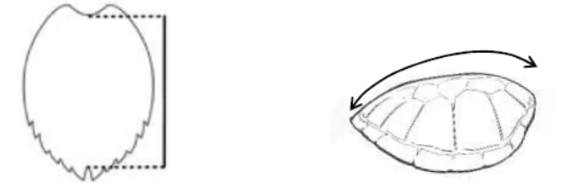
Step 4 | Photograph the whole animal and zoom in on: 1) the carapace and plastron;2) the top of the head (from the top); 3) the head right and left profile; 4) unusual marks and scar. Number all the photos taken and catalogue each photo with the following information: species, sex, length.
Step 5 | Collect genetic samples from all sea turtles found to be sent to IFREMER;  Collect a small sample (0.5cm) of the soft tissues located between the scales of the posterior or anterior fins, using the same material and protocol as for the collection of crustacean genetic samples.

Marine mammals and marine birds interactions
Stage | Description
Step 1 | One surveyor will be dedicated to record marine mammal and seabird’s interactions with trawling activities.  Surveyor will survey trawl shooting and hauling activities from a high point on the back of the boat.  Surveyor will record any cetacean or seabird interaction with the vessel during shooting, hauling of the trawl and during the discarding of the catch (if any).
Stage | Description
Step 2 | Surveyor will record during each survey period the following information (in the effort sheet provided):  - Date (dd;mm;yy);  - Time (hh;mm);  - Position (latitude and longitude);  - Environmental data as per requested.
Step 3 | - For each sighting surveyor will record in the sighting sheet provided:  - Time;  - Position (latitude and longitude);  - Species;  - Number (minimum, maximal and best estimate);  - Distance (in meters);  - Behaviour (travelling, resting, feeding/foraging, milling, unknown)  - Don’t hesitate to add comments and to take photos for species ID confirmation.

Sharks interactions
Record any sharks interactions (or not) associated with the trawl operation. Thus document absence or presence (and behaviour) of sharks when deploying, lifting each trawl and/or discarding the catch.

4. GENERAL

4.1 Data and samples

Property
- All data and samples collected during the cruise are the property of the SWIOFP;
- Under no circumstances are any samples to be taken off the vessel until the ship reaches its final destination (i.e. Dar es Salaam for the Tanzania survey and Mombasa for the Kenya survey);

Handling of survey data and samples
- Data to be recorded in hard copy first on sampling sheets provided by SWIOFP and/or individual researchers;
- Data to be captured onto Nansis database on a daily basis if possible. A Laptop with Nansis software is provided by RCC1 for this purpose;
- Each and every scientist on-board to be provided with a CD containing all the data collected during the survey;
- SWIOFP RMU, RCC1 and RCC2 to be provided with a CD containing all the data collected during the survey. CDs are to be properly labelled and stored together with the laptop provided containing Nansis data-base.
- Samples are to be allocated as per established in table 3. If any extra samples are collected during the cruise they should be entered in sailing orders sample table.
- A spread-sheet detailing all samples collected during the survey (station, number and species), samples final destination, samples purpose, person or institution responsible for its storage and/or processing is to be forward to SWIOFP SLC not later than 7 days after the cruise.
- Trip report to be drafted by Cruise leader and submitted to SLC/RCC2 within 1 month of survey end.
- Technical Survey Report with survey plan, methods, data and samples collected to be drafted by Cruise leader and submitted to SLC/RCC2 within 3 months of survey end.
- Final Survey Report to be provided to SWIOFP RMU by RCC2.

Sample labelling system
All biological samples are to be labelled as follow:
  - Voyage: TZN2012C204
  - Date: [dd/mm/yy]
  - Station No.:
  - Species name (if known): [FAO 3 letters code]
All samples collected in the context of a scientific cooperation are to be labelled as follow:
  - Voyage TZN2012C204
  - Cooperation project: [3 letter code, see table 6]
  - Date: [dd/mm/yy]
  - Station No.:
  - Species name: [FAO 3 letters code]

Sample destinations
Preservation method | Species | N° to collect | Location to be sent/stored
90% alcohol (genetics)  Frozen whole | Deep-water lobster Palinurus spp | N/A | ORI for Johan Groeneveld
90% alcohol (genetics) and whole frozen | Langoustines spp | 40/spp | ORI, South Africa, MSc study Lourenzo Zacarias
90% alcohol (genetics) | Lobsters spp | 40/spp | TAFIRI, Tanzania
90% alcohol (genetics) | Crabs spp | 40/spp | TAFIRI, Tanzania
90% alcohol (genetics) | Deep-water prawns spp | 40/spp | TAFIRI, Tanzania
90% alcohol (genetics) and whole frozen | Deep-water prawns Haliporoides triarthrus | 40/spp | ORI, South Africa, MSc study Lourenzo Zacarias
90% alcohol (genetics) | P. coeruleopunctatus (20-30 cm total length) | 50 | TAFIRI, Tanzania
90% alcohol (genetics) | P. filamentosus, (40-50 cm total length) | 30/spp | Moi University, Kenya
90% alcohol (genetics) | All species of fish | 5/spp | Barcode of Life project, SAIAB, South Africa for Dr Allan Connell
Dry (otoliths) | P. coeruleopunctatus | (seeabove) | TAFIRI
Dry (otoliths) | P. filamentosus, | (see above) | Moi University, Kenya
Frozen whole | Fish and crustaceans spp | N/A | SAIAB (Grahamstown)
5% formalin (identification) | Fish sp. | N/A | SAIAB (Grahamstown)
Alcohol at 80% | Turtle sp. | 1 per individual | IFREMER La Réunion, France
Table 3- Samples type and destination

4.2 Scientific organisation
Cruise leader (CL)
In charge of communications with the FV Captain and country authorities; to establish link between the Captain and the scientific team; In charge of scientific crew and of taking decisions that affect the scientific outcome of the survey; In charge of distribution of samples to final destinations. To supplying SLC with list of the samples collected during the survey in Excel format. Goals are to optimise survey by relying on existing fisher and scientific expertise. To follow up on all sampling activities conducted during the survey. To ensure that samples are correctly collected, preserved, labelled and stored. To direct scientific activities; organize scientific work (per discipline or projects); appoint teams and team leaders. CL decisions that might affect FV planned activities or vessel safety to be discussed with FV Captain.

Overall Chief Scientist (shore based)
To follow survey from shore and to provide CL with information that off importance to the optimisation of the survey (ex: satellite information, etc).

Project Leaders (PL)
To interact with CL and provide information on project level workplans and changes in sampling strategy. To highlight scientific findings and problems associated with their project.
Issues resulting from conflict between FV crew and scientific crew to be resolved between CL, and FV Captain.

4.3 Cooperation, training and capacity building
An important component of SWIOFP Projects is to provide training and research opportunities to students and scientists from the partner countries. Building capacity and the development of new knowledge will be combined by providing technical assistance in ship-based sampling to better understand ecosystem composition and functioning, assessing the primary biological and ecological interactions in the food web and the direct interactions brought about by the fisheries in the ecosystem.

4.3.1 Cooperation projects:

1. SWIOFP MSc – Lourenzo Zacarias: Population genetic analysis of langoustine Metanephrops mozambicus and knife prawn Haliporoides triarthrus populations occurring in Mozambique and South Africa
Project partners are IIP, ORI, UKZN, SWIOFP
Project to be extended regionally within SWIOFP region (Tanzania, Kenya, Madagascar) through collaboration with local scientists and research institutes. Project relies on samples collected during deep-water trawl surveys.

2. SWIOFP MSc – James Robey: Biology and fisheries of langoustine Metanephrops mozambicus and knife prawn Haliporoides triarthrus populations occurring in South Africa and Mozambique
Project partners are ORI, UKZN, IIP, SWIOFP
Project to be extended regionally within SWIOFP region (Tanzania, Kenya, Madagascar) through collaboration with local scientists and research institutes. Project relies on samples collected during deep-water trawl surveys.

3. P. coeruleopunctatus project, TAFIRI, Dar es Salaam, Tanzania

Although this is a SWIOFP priority species, there is no specific SWIOFP project for this species; the langoustine survey presents an opportunity to obtain data on of this species. Objective: Collection of genetic/biological/age data from trawled catches to complement similar data from other sources.

4. P. filamentosus Moi University, Mombasa, Kenya
This is a SWIOFP priority species, and samples will be used to examine genetic connectivity in the SWIO region. Objective: Collection of genetic/biological/age data from trawled catches to complement similar data from other sources.

5. SWIOFP deep-water spiny lobster genetics project
Ongoing SWIOFP project looking at genetic connectivity between deep-water spiny lobster populations (mainly Palinurus and Jasus spp) occurring through-out the SWIOFP and neighbouring areas. Project partners are ORI, University of Stellenbosch, SWIOFP. Project relies on samples collected during SWIOFP trapping and trawling surveys.

6. Barcode of Life project

Ongoing genetic project looking at genetic connectivity between demersal fish species populations occurring in South Africa and in Tanzania. Project partners are TAFIRI, SAIAB, BoL project.

7. Genetic Turtles, IFREMER/KELONIA, La Réunion, France
This programme is the first regional program aiming to evaluate the genetic diversity of marine turtles in the SWIO region, to identify the various sub-populations and identify their foraging distributions. When complete it will prove possible to determine a sound conservation strategy for the region.
In the context of this project, partners requested for the collection of sea-turtles genetic samples and associated information as per protocol presented in chapter 3.1.3 Biodiversity.

8. Sea-turtle Identification, IFREMER/Kelonia, La Réunion, France
Photo-identification can be an alternative method to identify and track individual sea-turtles over time, contributing therefore to the analysis of marine turtles nesting and feeding sites fidelity. It might be used as a complement to the usual “capture-tag-recapture” methods, and thus compensating for tag losses. It is particularly interesting in places where marine turtles cannot be caught and tagged. It is the case of many areas in the SWIO. This technique was developed by Kelonia, and uses photos of marine turtle head profiles. It consists in analysing scutes number and form of both right and left profiles. Head scute patterns are unique for each individual turtle and remain unchanged over time. Profile images can therefore be used to identify individual turtles, in the same way fingerprints are used for humans. A database has been created to keep these photos and convert them into fingerprints.
In the context of this project, partners requested for the collection of se-turtles profile photos and associated information as per protocol presented in chapter 3.1.3 Biodiversity.

Project | Partner | Code
1. Population genetics of langoustine Metanephrops mozambicus and knife prawn Haliporoides triarthrus | ORI, IIP, UKZN, SWIOFP
2. Biology and fisheries of langoustine Metanephrops mozambicus and knife prawn Haliporoides triarthrus | ORI, IIP, UKZN, SWIOFP
3. P. coeruleopunctatus project | TAFIRI | PCP
4. P. filamentosus | Moi University | PFI
5.SWIOFP deep-water spiny lobster genetics project | ORI, University of Stellenbosch, SWIOFP
6. Barcode of Life project | Barcode of Life project, SAIAB, South Africa for Dr Allan Connell | BLP
7. Genetics of Sea Turtles in the SWIO | IFREMER / KELONIA, La Réunion, France. | GST
8. Sea-turtle Identification | IFREMER / KELONIA, La Réunion, France. | TID
Table 6 – Project names, codes and destination.

4.4 Waste Management
Waste management on-board should follow MARPOL Convention regulations (see Appendix B: MARPOL Convention Annex V on waste management). All chemical waste (chemicals from the laboratories must be stored in separate containers (preferably glass) and correctly labelled with the chemical name and the word WASTE. Under no circumstances may the following take place:
  - Dumping chemical waste down the drain or over the side
  - Mixing of chemical waste (only one chemical per bottle allowed)

Note: It is the Chief Scientist’s responsibility to ensure the following with regard to hazardous materials:
  - MSDS sheets are to be furnished for each hazardous material (3 copies)
  - All hazardous material users are to be trained in their use
  - Personal Protective Equipment (PPE) are to be provided to the users
  - Emergency spill kits must accompany any hazardous material brought aboard

4.5 Code of Conduct, Safety Awareness & Safety at Sea
SWIOFP survey cruises Code of Conduct and Safety at Sea and Safety Awareness Rules are detailed in appendix C, D & E. This rules and regulations apply to all scientific personnel embarked on a SWIOFP survey cruise, please follow them carefully.
Note:
- Failure to comply with code of conduct will result in you not being allowed to embark with another SWIOFP survey cruise.

Appendix A: SWIOFP data sheets to be used during survey
- Form 1_ Vessel and Trip Information_EN_FR
- Form 2A_Gear_ Trawl_EN_FR
- Form 3A_Effort_Trawl_EN_FR
- Form 4_ Marine mammal, Sea turtle, and Seabird Incidental Take_EN_FR
- Form 5_Marine mammal and seabird observation_EN_FR
- Form 6_Depredation_EN_FR
- Form 7_Fish Bio_EN_FR
- Form 8_Crustacean Bio_EN_FR
- Form 9_ Turtle Bio_EN_FR
- Form 10_photo logbook_EN_FR
- Nansis Trawl form_EN

Appendix B: Trawlable positions of the continental slope of Tanzania

The South African trawler “Ocean Surf” did some experimental trawling for langoustines, lobster and deep-water prawn off Tanzania in 2004. Fishing positions, depths, catches and comments have kindly been provided by the vessel owner.(see below).

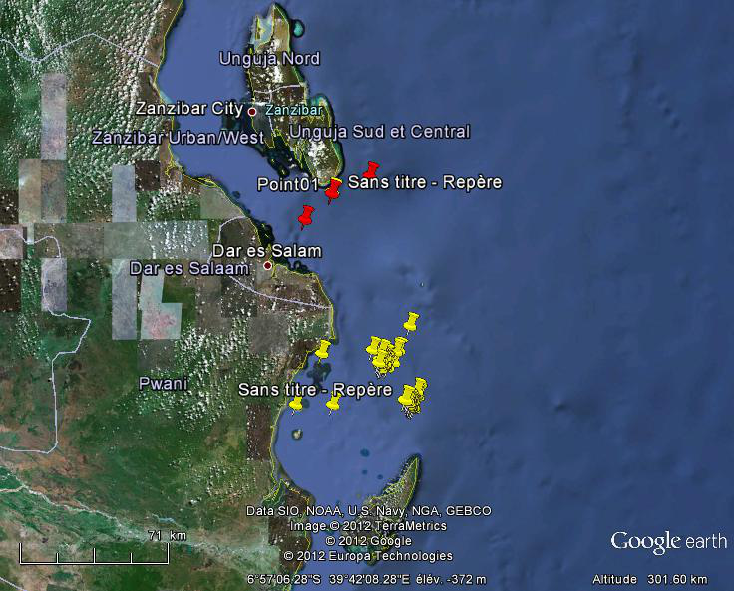

Latitude |  | Longitude |  | Depth (m)
Degrees | Minutes | Degrees | Minutes | Depth (m)
6 | 29,2 | 39 | 41,5 | 510
6 | 33,7 | 39 | 31,8 | 292
6 | 40,3 | 39 | 24,9 | 319

Table 1 - Fishing positions Area 1- Dar es Salaam.

Latitude |  |  | Longitude |  |  |  | Depth (m)
Degrees |  | Minutes |  | Degrees |  | Minutes
7 | 7,4 |  | 39 |  | 51,8 |  | 312
7 | 13,5 |  | 39 |  | 42,2 |  | 288
7 | 13,6 |  | 39 |  | 48,9 |  | 354
7 | 14 |  | 39 |  | 48,2 |  | 341
7 | 14,1 |  | 39 |  | 44,5 |  | 357
7 | 14,4 |  | 39 |  | 29,2 |  | 354
7 | 15,2 |  | 39 |  | 45,5 |  | 315
7 | 15,2 |  | 39 |  | 45,8 |  | 317
7 | 16 |  | 39 |  | 43,9 |  | 304
7 | 16 |  | 39 |  | 44,5 |  | 310
7 | 16,7 |  | 39 |  | 47,6 |  | 312
7 | 16,8 |  | 39 |  | 43,8 |  | 303
7 | 16,8 |  | 39 |  | 44,4 |  | 306
7 | 16,8 |  | 39 |  | 45,6 |  | 321
7 | 16,9 |  | 39 |  | 45,4 |  | 317
7 | 17 |  | 39 |  | 44 |  | 304
7 | 17,1 |  | 39 |  | 44,6 |  | 310
7 | 17,1 |  | 39 |  | 45,5 |  | 315
7 | 17,2 |  | 39 |  | 45,3 |  | 315
7 | 17,5 |  | 39 |  | 45,5 |  | 315
7 | 17,6 |  | 39 |  | 44,2 |  | 304
7 | 17,9 |  | 39 |  | 44,9 |  | 312
7 | 17,9 |  | 39 |  | 46,1 |  | 321
7 | 18,1 |  | 39 |  | 44,6 |  | 308
7 | 18,2 |  | 39 |  | 44,4 |  | 306
7 | 24 |  | 39 |  | 53,6 |  | 354
7 | 24,5 |  | 39 |  | 53,7 |  | 348
7 | 25 |  | 39 |  | 54 |  | 352
7 | 25,2 |  | 39 |  | 53,9 |  | 346
7 | 26,4 |  | 39 |  | 51,3 |  | 314
7 | 26,5 |  | 39 |  | 50,5 |  | 310
7 | 26,9 |  | 39 |  | 51,5 |  | 312
7 | 26,9 |  | 39 |  | 51,7 |  | 314
7 | 27,2 |  | 39 |  | 51,7 |  | 312
7 | 27,5 |  | 39 |  | 51,6 |  | 312
7 | 27,5 |  | 39 |  | 51,5 |  | 312
7 | 27,5 |  | 39 |  | 22,5 |  | 314
7 | 27,5 |  | 39 |  | 32 |  | 315
7 | 27,6 |  | 39 |  | 52,1 |  | 314
7 | 27,7 |  | 39 |  | 52,2 |  | 312
7 | 27,7 |  | 39 |  | 51,9 |  | 312
7 | 27,7 |  | 39 |  | 51,9 |  | 312
7 | 28 |  | 39 |  | 52,7 |  | 314
7 | 28 |  | 39 |  | 51,9 |  | 314
7 | 28,1 |  | 39 |  | 52,7 |  | 314
7 | 28,2 |  | 39 |  | 52,2 |  | 312
7 | 28,4 |  | 39 |  | 52,9 |  | 314

Table 2 - Fishing positions Area 2- Mafia Channel.

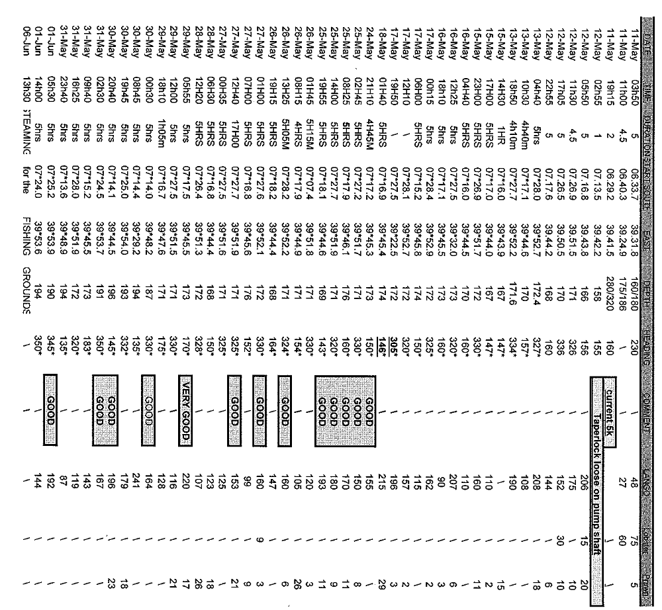

Table 3 – Full details from fishing positions in Area 1& 2 from SA trawler “Ocean Surf”

Appendix C: Polysteganus mascarenensis Identification

Appendix D: Fish Generic Maturity Stage Index

Appendix E: Environmental conditions

Appendix F: Biodiversity protocols
Figure 1 – Sea Turtles species ID
Figure 2 – Sea Turtles sex ID
Figure 3 – Sea turtle resuscitation methods
Figure 4 – Large whales dive blow, surfacing and dive sequences

Appendix G: MARPOL Convention (1973) Annex V – Regulations for the prevention of pollution by garbage from ships; regulation 1, 2 & 3.

Appendix H: Conduct onboard

Appendix I: Safety at Sea

Appendix J: Safety Awareness

If the vessel is not capable to trawl to depths of 500-600 m then 500-600m depth stratum should be replaced with a 100-200m depth stratum.
To be replaced by 100-200 m depth stratum if vessel not capable to trawl to depths of 500-600 m.
For cetacean species ID report to “SPC Marine species identification manual for Horizontal Longline Fishermen”

